Using a Sankey diagram
Aims
It is important that you know the different forms of energy and understand where most energy goes in a series of changes. In this worksheet you will practise using a number of energy terms and calculate amounts of energy and the overall efficiency of a process.
Questions
Look at the Sankey diagrams. They show the operation of one complete cycle of a cordless electric drill.
The left diagram shows the charging of the battery inside the drill. The right diagram shows the later use of the battery in the drill. The amount of energy transferred to the surroundings as sound is so small that it is not shown.
Think about what is happening at the different stages. Think about the changes during charging of the battery and changes when the drill is being used to do some work.

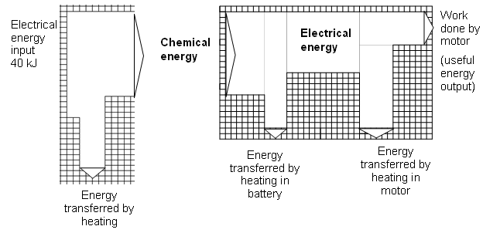

40 kJ of electrical energy is input into the battery as the battery is charged. The drill is later switched on until the battery becomes flat.

- Describe in words the useful and wasted energy changes that take place

- when the battery is being charged

………………………………………………………………………………………………………

………………………………………………………………………………………………………

- when the drill is switched on.

………………………………………………………………………………………………………

………………………………………………………………………………………………………

………………………………………………………………………………………………………

- The electrical energy input on the diagram is 40 kJ. If you count the “length” of the energy input you will see it is 20 squares vertically. If the side of one square is taken as 2 kJ then you can find any energy input or output by counting the number of squares along one side.
Using the squares marked on the diagram, calculate

- the chemical energy stored in the battery.

number of squares = …………………. chemical energy = ……………….

- the energy transferred by heating during charging.

number of squares = …………………. heat = ……………………………

- the work done by the motor.

number of squares = …………………. work done = ………………

- Use your answers from b to calculate the overall efficiency in converting the input electrical energy (40 kJ) into work done by the motor. Give your answer as a number and a percentage.

efficiency as a number = …………………….

efficiency as a percentage = ……………….

- The useful energy from the drill is the energy used for the work done. The overall efficiency of the drill in converting the input energy supplied to useful energy is increased to 50%

- Write down the equation that shows the efficiency (as a number), useful energy output (work done) and energy supplied.

- Use your equation to find the work done by the motor when the electrical input energy is 40 kJ.

Work done = …………………………
- What is the electrical input energy when the useful work output is 70 kJ?

input energy = ………………………..

- Repeat the calculations in d ii and d iii when the efficiency of the drill is 70%.

